**Python Advanced course1**

*# print("hello"[0])*num_char=len(input("what is your name ?"))  
new_num_char=str(num_char)  
print("your name has " + new_num_char + " characters.")  
*# print(type(num_char))*

*# a=str(123)  
# print(type(a))  
# a=float(123)  
# print(type(a))  
# print(70+ float("100.5"))# 170.5  
# print(str(70)+ str(100.5))#70100.5*

*# enter a two digit number and add their digits with each other*two_digit_number=input("enter two digit numbers")  
first_digit=two_digit_number[0]  
second_digit=two_digit_number[1]  
result=int(first_digit)+int(second_digit)  
print(result)

OR

*# enter a two digit number and add their digits with each other*two_digit_number=input("enter two digit numbers")  
first_digit=int(two_digit_number[0])  
second_digit=int(two_digit_number[1])  
result=first_digit+second_digit  
print(result)

///////////////////////////////////////////////////////////////

*# print(type(9/3))  
# print(3*3+3/3-3)  
# print(3*1+9/3-3)  
# print(3*(3+3)/3-3)*

*# print(3*1+9/3-3)  
# print(3*(3+3)/3-3)  
# How to calculate Body index rom a person weight and Height  
#BMI=weight(kg)/Height^2(m)  
# height=input("enter your height in m:")  
# weight=input("enter your weight in kg:")  
# new_height=float(height)  
# new_weight=float(weight)  
# new_height2=pow(new_height,2)  
# BMI= new_weight / new_height2  
# print(BMI)  
#OR*height=input("enter your height in m:")  
weight=input("enter your weight in kg:")  
BMI= int(weight) / float(height)**2  
bmi_int=int(BMI)  
print(bmi_int)

*# how to use round functions  
# print(round(8/3))  
# print(round(8/3,2))  
# print(round(8.34582673533,2))  
# # use of floor  
# print(8//3)  
# result=8//3  
# result //=2  
# print(result)  
# score=0  
# score +=1  
# score -=1  
# print("This is your score "+str(score))*score=0  
height=1.0  
iswinning=True  
*# f-string*print(f"your score is {score},your height is {height},you are winning{iswinning}")

/////////////////////////////////////////////////////////////////////////////////////////

*# how to calculate your life from 90 years life expectation*age=input("what is your current age in normal year ? : ")  
age_as_int=int(age)  
years_remainaing=90 - age_as_int  
days_remainaing=years_remainaing*365  
weeks_remaining=years_remainaing*52  
months_remaining=years_remainaing*12  
hours_remaining=years_remainaing*8760  
minutes_remaining=years_remainaing*525600  
secounds_remaining=years_remainaing*31536000  
message=f"You have {days_remainaing} days,{weeks_remaining} weeks, " \  
 f"{weeks_remaining} months,{hours_remaining} hours ," \  
 f"{minutes_remaining} minutes,and {secounds_remaining} seconds left."  
print(message)

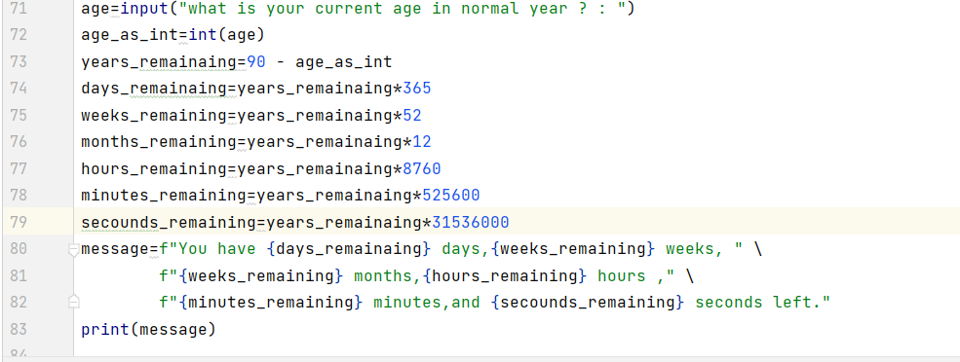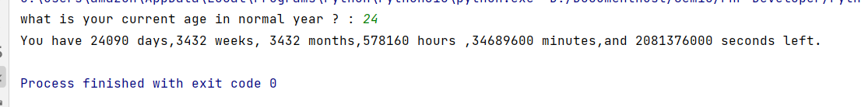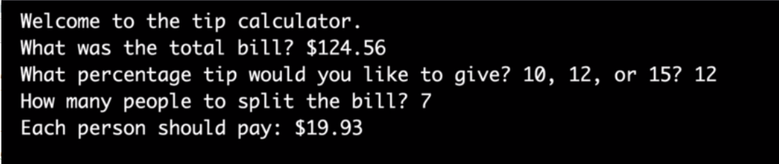

*# now build a tip calculator*print("Welcome to the tip calculator !")  
bill=float(input("What was the total bill? $"))  
tip=int(input("How much tip would like to give? 10,12,or 15? "))  
people=int(input("How many people to splits the bill?"))  
bill_with_tip=tip / 100*bill+bill  
print(bill_with_tip)

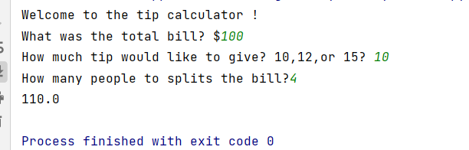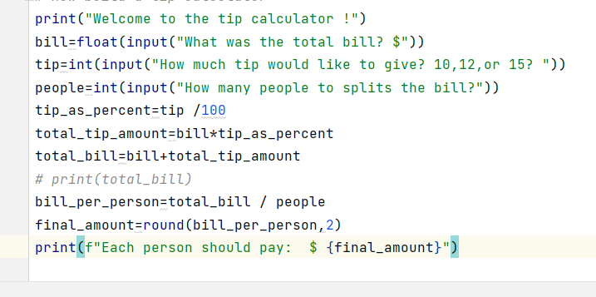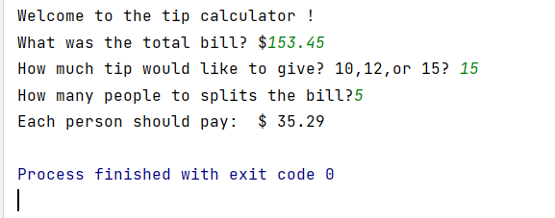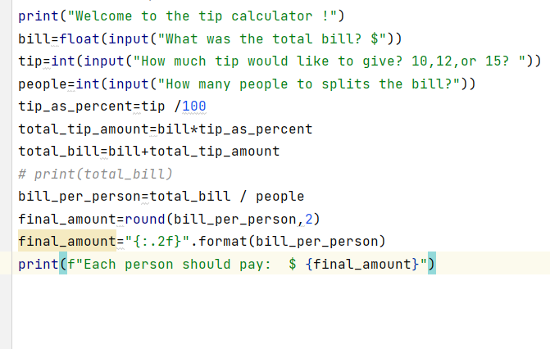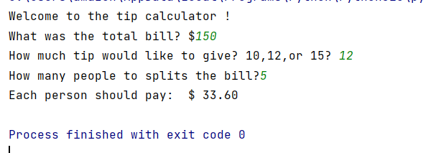

*# now build a tip calculator*print("Welcome to the tip calculator !")  
bill=float(input("What was the total bill? $"))  
tip=int(input("How much tip would like to give? 10,12,or 15? "))  
people=int(input("How many people to splits the bill?"))  
tip_as_percent=tip /100  
total_tip_amount=bill*tip_as_percent  
total_bill=bill+total_tip_amount  
*# print(total_bill)*bill_per_person=total_bill / people  
final_amount=round(bill_per_person,2)  
final_amount="{:.2f}".format(bill_per_person)  
print(f"Each person should pay: $ {final_amount}")

/////////////////////////////////////////////////////////////////////////////////////

**Treasure Islands :**

print('''  
*******************************************************************************  
 | | | |  
 _________|________________.=""_;=.______________|_____________________|_______  
| | ,-"_,="" `"=.| |  
|___________________|__"=._o`"-._ `"=.______________|___________________  
 | `"=._o`"=._ _`"=._ |  
 _________|_____________________:=._o "=._."_.-="'"=.__________________|_______  
| | __.--" , ; `"=._o." ,-"""-._ ". |  
|___________________|_._" ,. .` ` `` , `"-._"-._ ". '__|___________________  
 | |o`"=._` , "` `; .". , "-._"-._; ; |  
 _________|___________| ;`-.o`"=._; ." ` '`."\` . "-._ /_______________|_______  
| | |o; `"-.o`"=._`` '` " ,__.--o; |  
|___________________|_| ; (#) `-.o `"=.`_.--"_o.-; ;___|___________________  
____/______/______/___|o;._ " `".o|o_.--" ;o;____/______/______/____  
/______/______/______/_"=._o--._ ; | ; ; ;/______/______/______/_  
____/______/______/______/__"=._o--._ ;o|o; _._;o;____/______/______/____  
/______/______/______/______/____"=._o._; | ;_.--"o.--"_/______/______/______/_  
____/______/______/______/______/_____"=.o|o_.--""___/______/______/______/____  
/______/______/______/______/______/______/______/______/______/______/_____ /  
*******************************************************************************  
''')  
print("Welcome to Treasure Island.")  
print("Your mission is to find the treasure.")  
  
*#Write your code below this line*choice1 = input('You\'re at a cross road. Where do you want to go? Type "left" or "right" \n').lower()  
if choice1 == "left":  
 choice2 = input('You\'ve come to a lake. There is an island in the middle of the lake. Type "wait" to wait for a boat. Type "swim" to swim across. \n').lower()  
 if choice2 == "wait":  
 choice3 = input("You arrive at the island unharmed. There is a house with 3 doors. One red, one yellow and one blue. Which colour do you choose? \n").lower()  
 if choice3 == "red":  
 print("It's a room full of fire. Game Over.")  
 elif choice3 == "yellow":  
 print("You found the treasure! You Win!")  
 elif choice3 == "blue":  
 print("You enter a room of beasts. Game Over.")  
 else:  
 print("You chose a door that doesn't exist. Game Over.")  
 else:  
 print("You get attacked by an angry trout. Game Over.")  
else:  
 print("You fell into a hole. Game Over.")

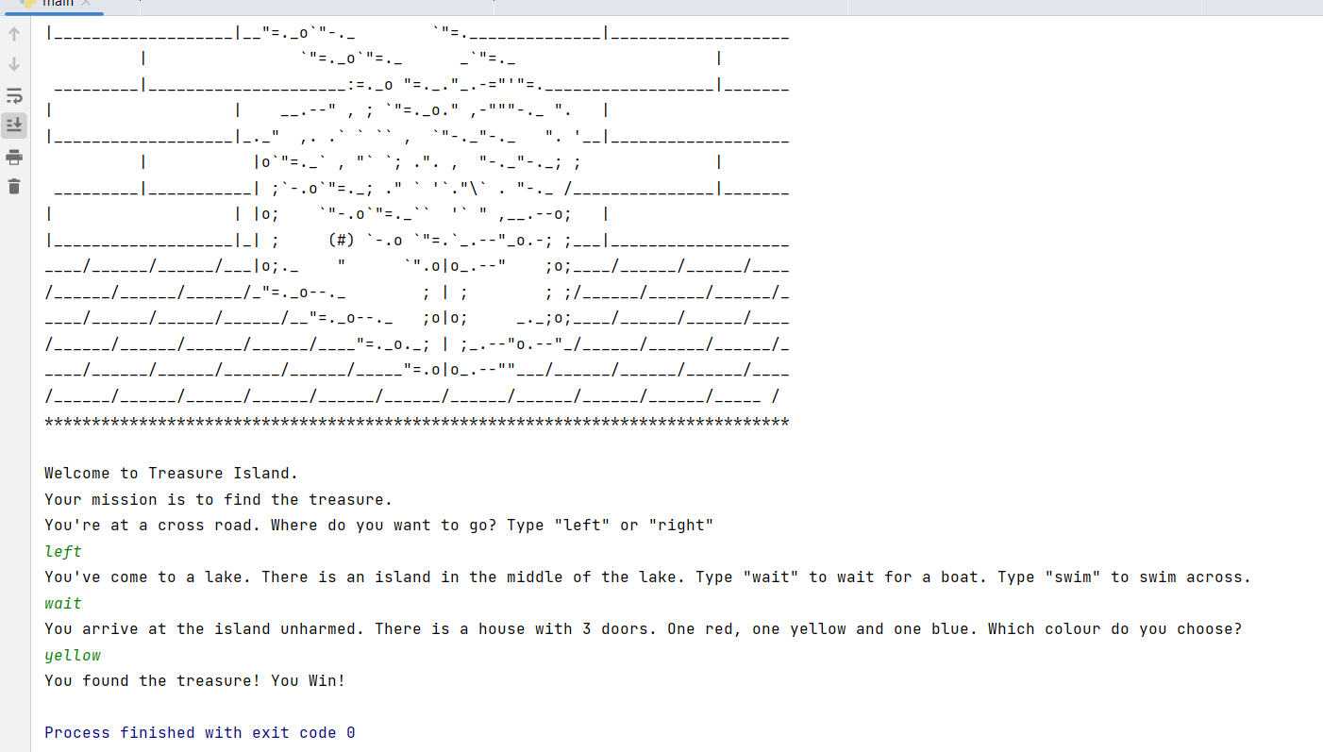

*# print("Welcome to the rollercoaster!")  
# height=int(input("What is your height in cm? "))  
# if height!=120:  
# print("You can ride the rollercoaster!")  
# else:  
# print("Sorry,you have to grow taller before you can ride. ")  
# n=int(input("which number do you want to check "))  
# if n%2== 1:  
# print("This is odd number ")  
# elif n%2 == 0:  
# print("This is even number")  
# else:  
# print("the number is zero")  
# nested if else statments*print("Welcome to the rollercoaster!")  
height=int(input("What is your height in cm? "))  
if height>=120:  
 print("You can ride the rollercoaster!")  
 age=int(input("What is your age?"))  
 if age<12:  
 print("Please pay $5")  
 elif age<=18:  
 print("Please pay $7")  
 else:  
 print("Please pay $12 ")  
else:  
 print("Sorry,you have to grow taller before you can ride. ")

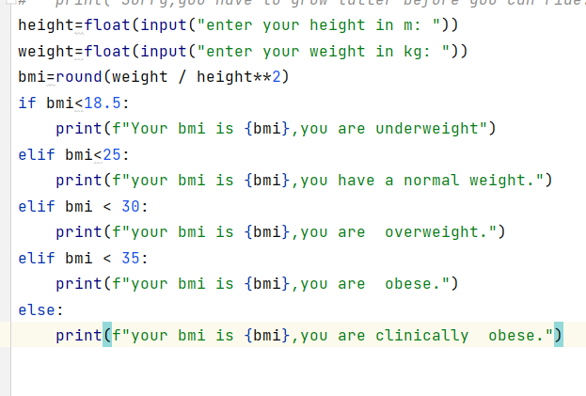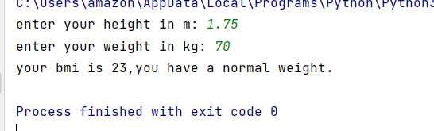

height=float(input("enter your height in m: "))  
weight=float(input("enter your weight in kg: "))  
bmi=round(weight / height**2)  
if bmi<18.5:  
 print(f"Your bmi is {bmi},you are underweight")  
elif bmi<25:  
 print(f"your bmi is {bmi},you have a normal weight.")  
elif bmi < 30:  
 print(f"your bmi is {bmi},you are overweight.")  
elif bmi < 35:  
 print(f"your bmi is {bmi},you are obese.")  
else:  
 print(f"your bmi is {bmi},you are clinically obese.")

//////////////////////////////////////////////////////////////////////////////////////////////

**Data Analysis :**

import pandas as pd  
*# xyz_web={'Day':[1,2,3,4,5,6],"Visitors":[1000,700,6000,1000,400,350],'Bounce_Rate':[20,20,23,15,10,34]}  
# df=pd.DataFrame(xyz_web)  
# # print(df)  
# # print(df.head(2))  
# print(df.tail(2))  
# df1=pd.DataFrame({"HPI":[80,90,70,60],"int_rate":[2,1,2,3],"IND_GDP":[50,45,45,67]},index=  
# [2001,2002,2003,2004])  
# df2=pd.DataFrame({"HPI":[80,90,70,60],"int_rate":[2,1,2,3],"IND_GDP":[50,45,45,67]},index=  
# [2005,2006,2007,2008])  
# # merge=pd.merge(df1,df2)  
# # print(merge)  
# merge=pd.merge(df1,df2,on="HPI")  
# print(merge)*

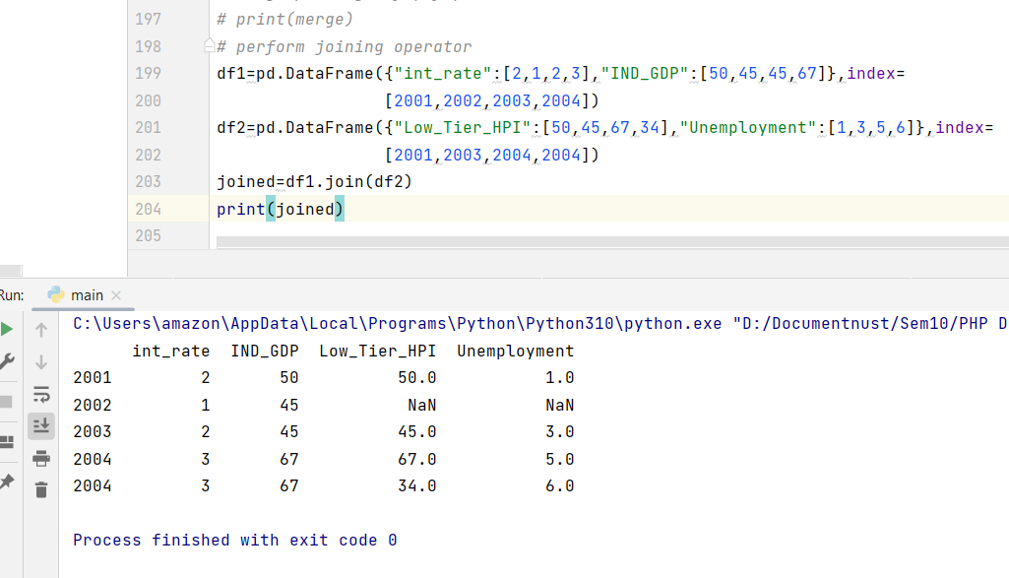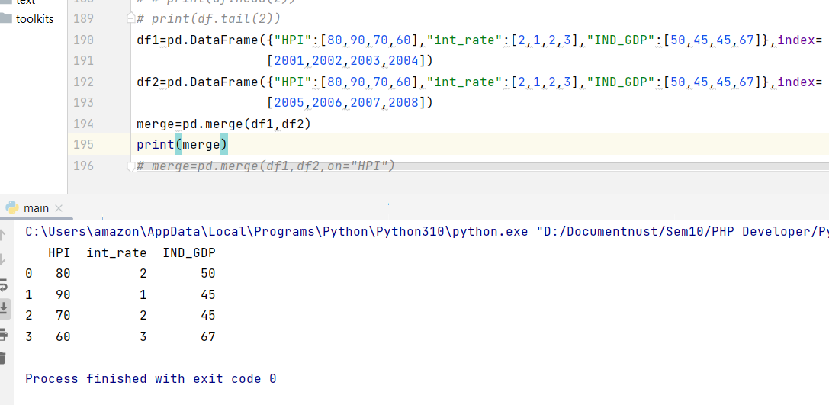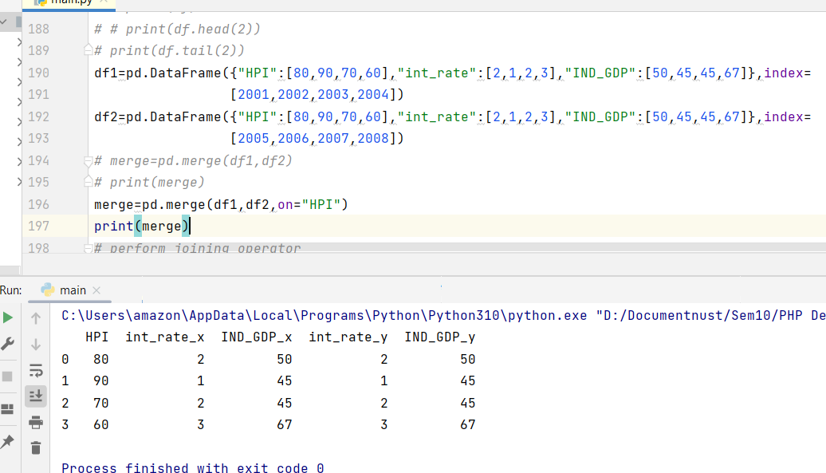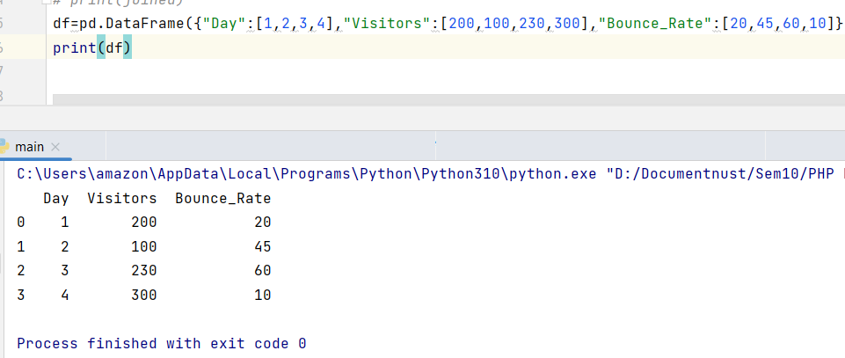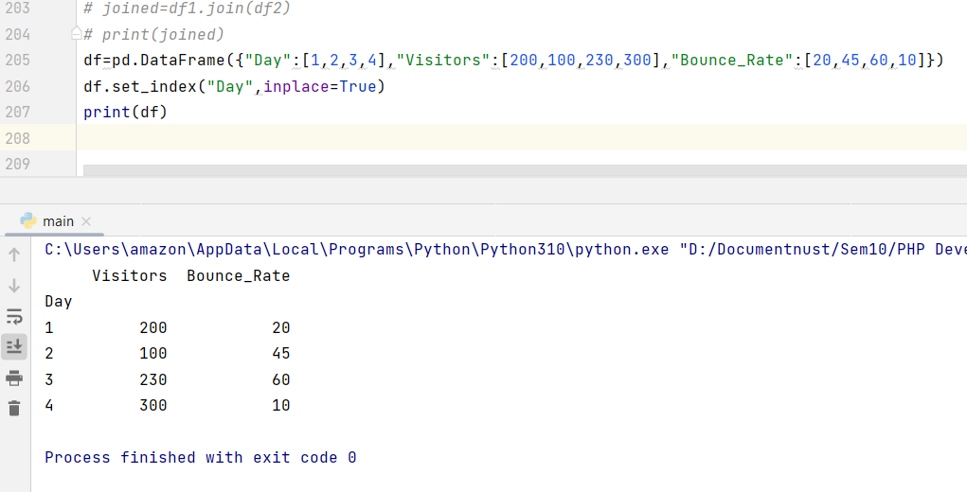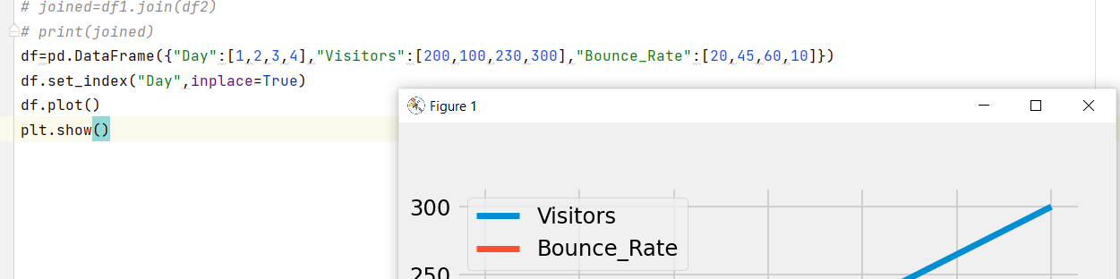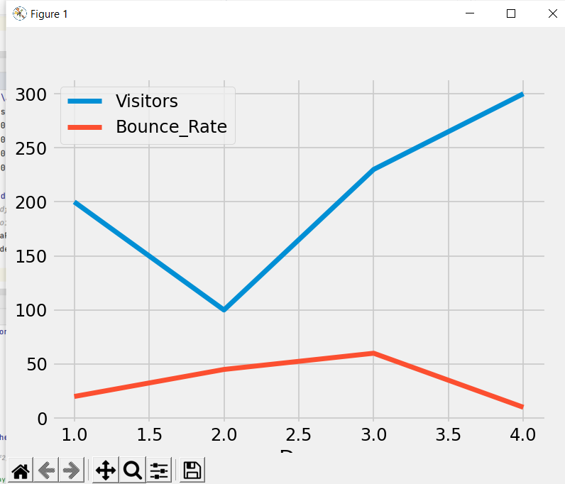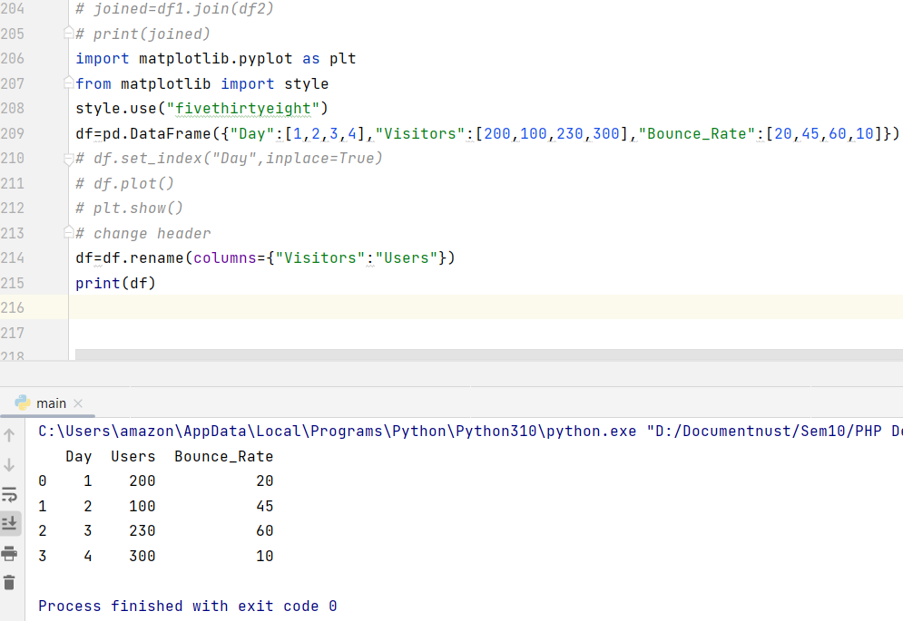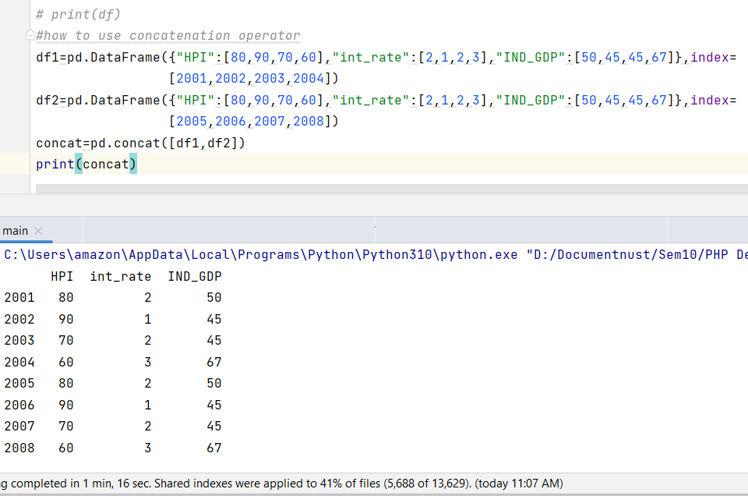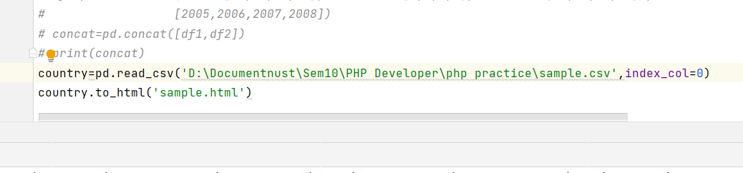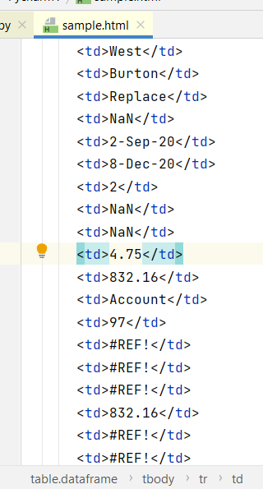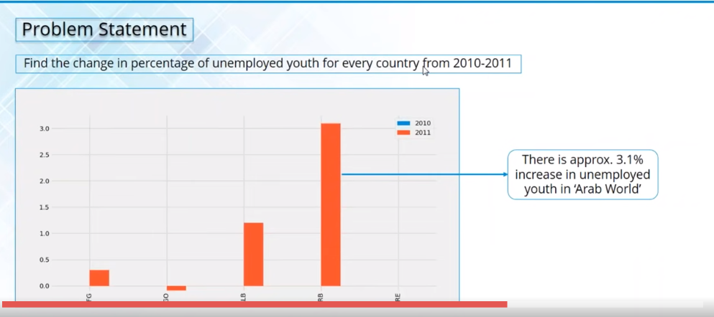

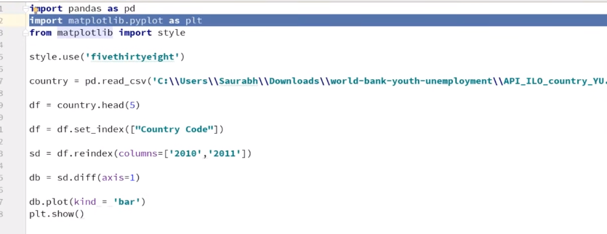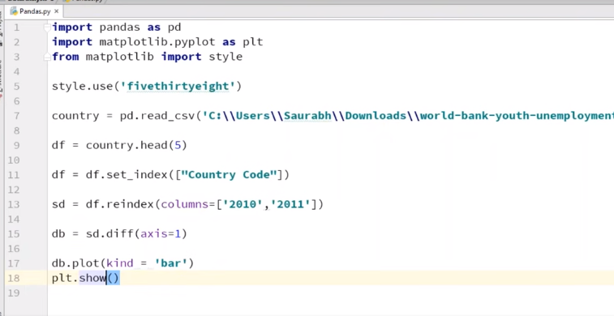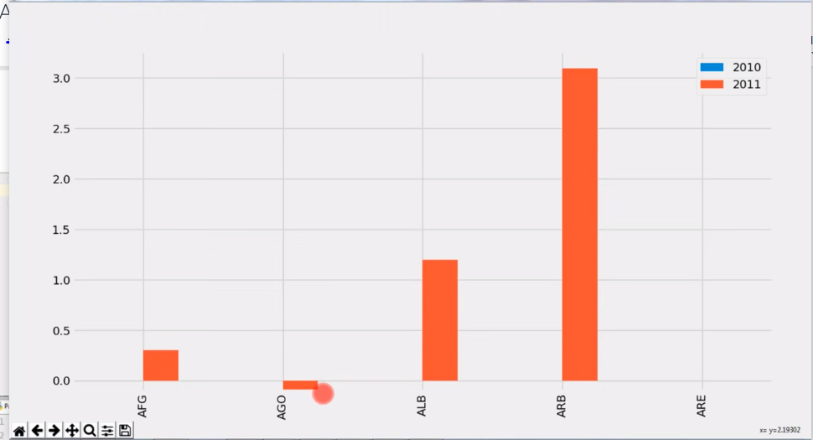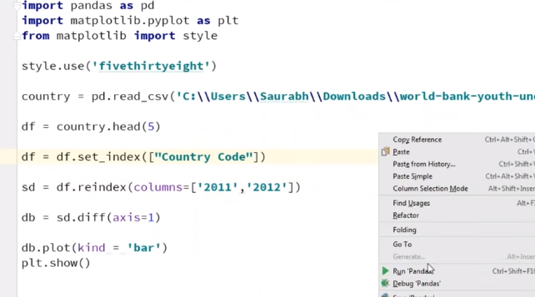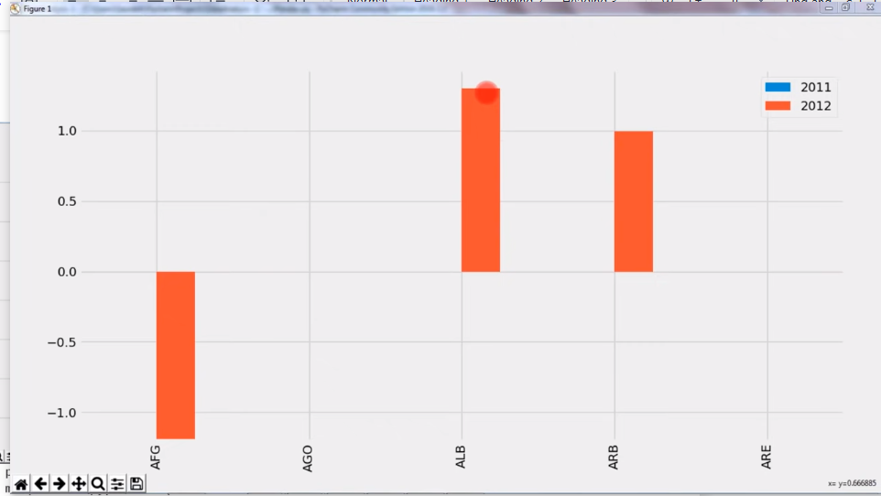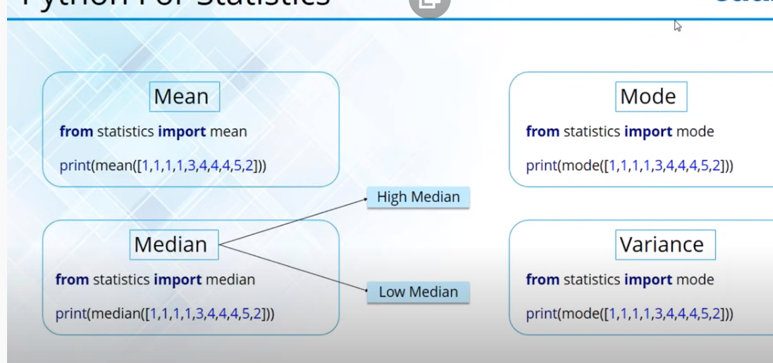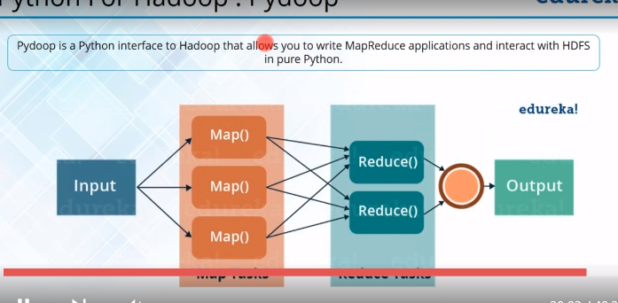

///////////////////////////////////////////

df1 = pd.DataFrame(  
 {  
 "A": ["A0", "A1", "A2", "A3"],  
 "B": ["B0", "B1", "B2", "B3"],  
 "C": ["C0", "C1", "C2", "C3"],  
 "D": ["D0", "D1", "D2", "D3"],  
 },index=[0, 1, 2, 3],  
 )  
df2 = pd.DataFrame(  
 {  
 "A": ["A4", "A5", "A6", "A7"],  
 "B": ["B4", "B5", "B6", "B7"],  
 "C": ["C4", "C5", "C6", "C7"],  
 "D": ["D4", "D5", "D6", "D7"],},index=[4, 5, 6, 7], )  
df3 = pd.DataFrame(  
 {  
 "A": ["A8", "A9", "A10", "A11"],  
 "B": ["B8", "B9", "B10", "B11"],  
 "C": ["C8", "C9", "C10", "C11"],  
 "D": ["D8", "D9", "D10", "D11"],  
 },  
 index=[8, 9, 10, 11],  
 )  
*# print(df1)  
# print(df2)  
# print(df3)*frames = [df1, df2, df3]  
result = pd.concat(frames)  
print(result)

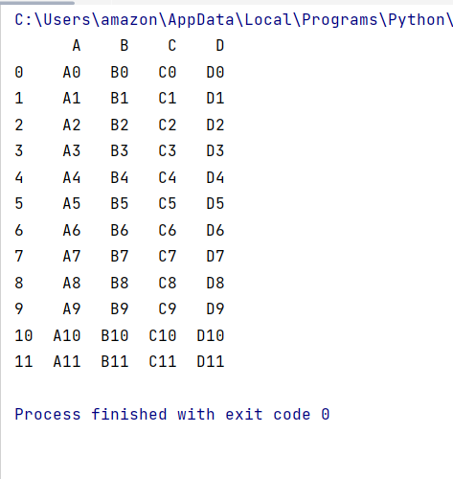

*# lets try some examples*df1 = pd.DataFrame(  
 {  
 "A": ["A0", "A1", "A2", "A3"],  
 "B": ["B0", "B1", "B2", "B3"],  
 "C": ["C0", "C1", "C2", "C3"],  
 "D": ["D0", "D1", "D2", "D3"],  
 },index=[0, 1, 2, 3],  
 )  
df2 = pd.DataFrame(  
 {  
 "A": ["A4", "A5", "A6", "A7"],  
 "B": ["B4", "B5", "B6", "B7"],  
 "C": ["C4", "C5", "C6", "C7"],  
 "D": ["D4", "D5", "D6", "D7"],},index=[4, 5, 6, 7], )  
df3 = pd.DataFrame(  
 {  
 "A": ["A8", "A9", "A10", "A11"],  
 "B": ["B8", "B9", "B10", "B11"],  
 "C": ["C8", "C9", "C10", "C11"],  
 "D": ["D8", "D9", "D10", "D11"],  
 },  
 index=[8, 9, 10, 11],  
 )  
*# print(df1)  
# print(df2)  
# print(df3)*frames = [df1, df2, df3]  
*# result = pd.concat(frames)  
# print(result)  
# result=pd.concat(  
# objs,  
# axis=0,  
# join="outer",  
# ignore_index=False,  
# keys=None,  
# levels=None,  
# names=None,  
# verify_integrity=False,  
# copy=True,  
# )*result = pd.concat(frames,keys=["x","y","z"])  
print(result)

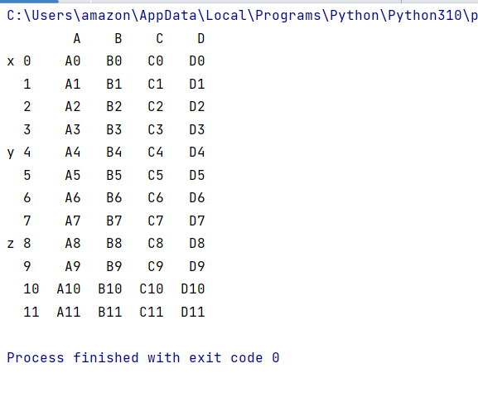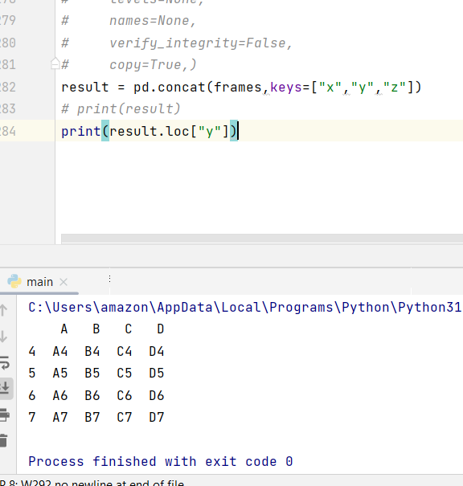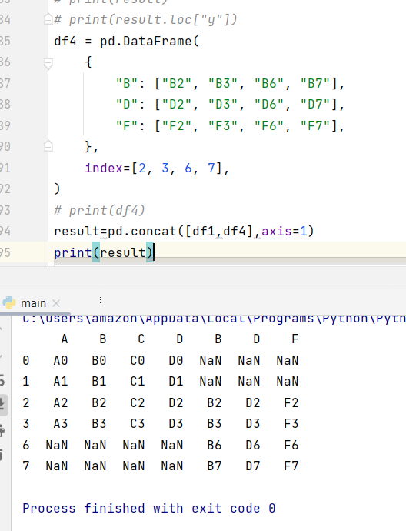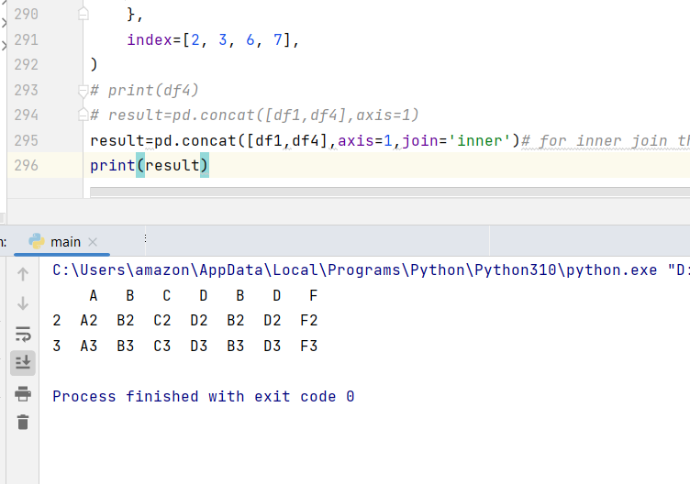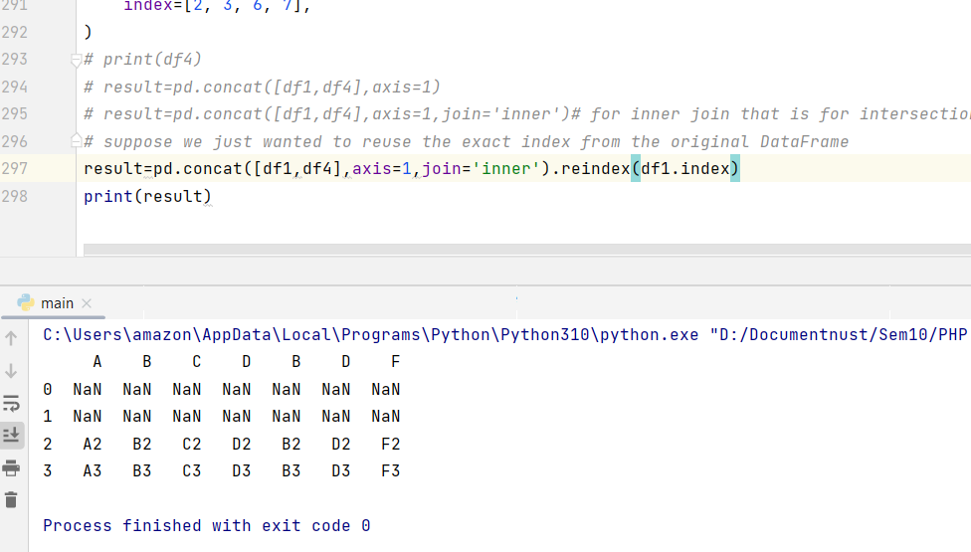

////////////////////////

import matplotlib.pyplot as plt  
from matplotlib import style  
style.use("fivethirtyeight")  
*# df=pd.DataFrame({"Day":[1,2,3,4],"Visitors":[200,100,230,300],"Bounce_Rate":[20,45,60,10]})  
# # df.set_index("Day",inplace=True)  
# # df.plot()  
# # plt.show()  
# # change header  
# df=df.rename(columns={"Visitors":"Users"})  
# print(df)  
#how to use concatenation operator  
# df1=pd.DataFrame({"HPI":[80,90,70,60],"int_rate":[2,1,2,3],"IND_GDP":[50,45,45,67]},index=  
# [2001,2002,2003,2004])  
# df2=pd.DataFrame({"HPI":[80,90,70,60],"int_rate":[2,1,2,3],"IND_GDP":[50,45,45,67]},index=  
# [2005,2006,2007,2008])  
# concat=pd.concat([df1,df2])  
# print(concat)  
# country=pd.read_csv('D:\Documentnust\Sem10\PHP Developer\php practice\sample.csv',index_col=0)  
# country.to_html('sample.html')  
# country = pd.read_csv('D:\Documentnust\Sem10\PHP Developer\php practice\sample.csv')  
# df=country.head(5)  
# # print(df)  
# df=country.head(5)  
# # df=df.set_index(['WO'])  
# sd=df.reindex(columns=['District','Service'])  
# db=sd.diff(axis=1)  
# db.plot(kind='bar')  
# plt.show()  
# from statistics import mean  
# from statistics import median  
# from statistics import mode  
# from statistics import variance  
# print(mean([1,1,1,1,3,4,4,5,2]))  
# print(median([1,1,1,2,2]))  
# print(mode([1,1,1,2,2]))  
# print(variance([1,1,1,2,2]))  
# lets try some examples*df1 = pd.DataFrame(  
 {  
 "A": ["A0", "A1", "A2", "A3"],  
 "B": ["B0", "B1", "B2", "B3"],  
 "C": ["C0", "C1", "C2", "C3"],  
 "D": ["D0", "D1", "D2", "D3"],  
 },index=[0, 1, 2, 3],  
 )  
df2 = pd.DataFrame(  
 {  
 "A": ["A4", "A5", "A6", "A7"],  
 "B": ["B4", "B5", "B6", "B7"],  
 "C": ["C4", "C5", "C6", "C7"],  
 "D": ["D4", "D5", "D6", "D7"],},index=[4, 5, 6, 7], )  
df3 = pd.DataFrame(  
 {  
 "A": ["A8", "A9", "A10", "A11"],  
 "B": ["B8", "B9", "B10", "B11"],  
 "C": ["C8", "C9", "C10", "C11"],  
 "D": ["D8", "D9", "D10", "D11"],  
 },  
 index=[8, 9, 10, 11],  
 )  
*# print(df1)  
# print(df2)  
# print(df3)*frames = [df1, df2, df3]  
*# result = pd.concat(frames)  
# print(result)  
# result=pd.concat(  
# objs,  
# axis=0,  
# join="outer",  
# ignore_index=False,  
# keys=None,  
# levels=None,  
# names=None,  
# verify_integrity=False,  
# copy=True,)  
# result = pd.concat(frames,keys=["x","y","z"])  
# print(result)  
# print(result.loc["y"])*df4 = pd.DataFrame(  
 {  
 "B": ["B2", "B3", "B6", "B7"],  
 "D": ["D2", "D3", "D6", "D7"],  
 "F": ["F2", "F3", "F6", "F7"],  
 },  
 index=[2, 3, 6, 7],  
)  
*# print(df4)  
# result=pd.concat([df1,df4],axis=1)  
# result=pd.concat([df1,df4],axis=1,join='inner')# for inner join that is for intersection  
# suppose we just wanted to reuse the exact index from the original DataFrame*result=pd.concat([df1,df4],axis=1,join='inner').reindex(df1.index)  
print(result)